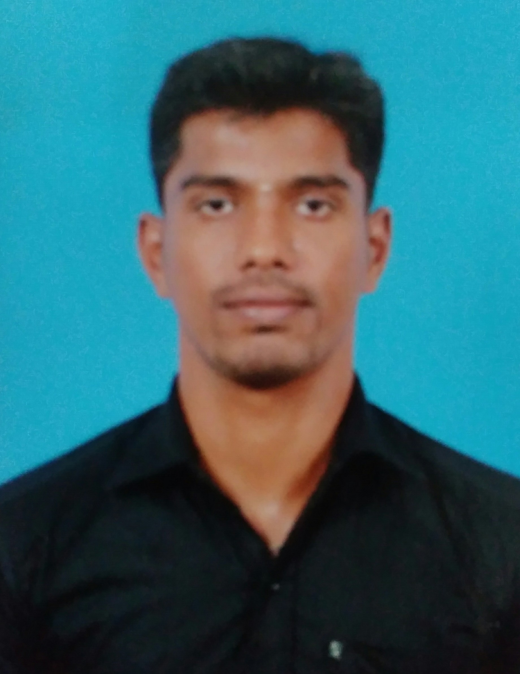
CURRICULUM VITAE
Dr. R. NANTHA KUMAR, M.Sc.,Ph.D.,
S/O V. Rangasamy
42, Mahali Amman Kovil Street,
Veerakeralam, Coimbatore-641007.
E-mail: nanthabio89@gmail.com
Phone: +919003564307.
Career Objectives
to accept challenging assignment in the field of botany to make a mark on myself in today’s expanding global business scenario.
Personal Details
Father’s name : Rangasamy.V
Date of Birth :07/07/1989
Phone : (+91) 9003564307, 7010000822
E-mail : nanthabio89@gmail.com
Contact Address : 42, Mahali Amman Kovil Street,Veerakeralam,
Coimbatore-641007, Tamilnadu.
Academic Performance
Ph.D (FT) (2013-2017)
Discipline : Botany
Commend : Highly Commended
Name of the Institution : Kongunadu Arts and Science College, Coimbatore.
Affiliated : Bharathiar University
M.Sc., (2010-2012)
Discipline : Botany
Percentage of marks : 73%
Name of the institution : Kongunadu Arts and Science College, Coimbatore.
Affiliated : Bharathiar University
B.Sc., (2007-2010)
Discipline : Plant Biology and Plant Biotechnology
Percentage of marks : 59.7%
Name of the institution : Goverment Arts College, Coimbatore
Affiliated : Bharathiar University
HSC (2005-2007)
Discipline : Pure Science,
Percentage of marks : 53.6%
Name of the institution : MSSD Higher Secondary School, Vadavalli, Coimbatore.
Affiliated : State Board, Tamilnadu.
Area of Interest
Medico Botany, Plant Tissueculture, Plant Therapeutics, Plant ecology, Nanotechnology, Plant Taxonomy, Ethanobotany and Pharmacological experiments.
Ph.D. Thesis Title
“Phytochemical and pharmacological investigations of Hydrocotyle conferta Wight (Apiaceae) – An endangered plant species from Southern Western Ghats, The Nilgiris, Tamilnadu, India.”
M.Sc. Dissertation Title
“Protocol for Micropropagation, Preliminary Phytochemistry and Antimicrobial activity of Medicinal shrub Rhinacanthus nasutus (L)Kurz. (Acanthaceae)”
Achievements/Awards
- NSS volunteer in Government Arts College, Coimbatore - 641 018.
Research Publications
- Nantha Kumar, R., Ganesan, C. M and Paulsamy,. S. 2012. Micropropagation of Rhinocanthus nasuta (L) Kurz.An Important Medicinal Plant. Research and Review: Journal of Botanical Sciences.1(1): 05-10.
- Udhayasankar, M. R., Danya, U.,Punitha, D., Arumugasamy, K and Nantha Kumar, R. 2013. In vitro antifungal activity of methanolic extract of Cardiospermum canescens wall.-a wild medicinal plant. World Journal of Pharmacy and Pharmaceutical Sciences. 2(6): 5128-5133.
- Nantha Kumar, R., Udhayasankar, M.R., Ashadevi,V., Arumugasamy, K and Shalimol, A. 2014. In vitro antimicrobial activity of aqueous and ethanol extracts of Rhinacanthus nasutus- a Medicinal plant. International Journal of Pharmaceutical, Chemical and Biological Sciences. 4(1):164-166.
- Asha Devi, V., Arumugasamy, K.A., Shalimol, A., Nantha Kumar, R., Udhayasankar, M.R and Kokilavani, R. 2014. Anti-Inflammatory Activity of Smilax wightii fruit, Endemic A.DC.(Smilacaceaea) -An Endangered Medicinal Plant from the Nilgiris. Journal of Pharmaceutical and Biological Research. 2(2): 136-138.
- Uma Maheswari, P., K. Arumugasamy, A. Shalimol, V. Asha devi and R. Nantha Kumar. 2014. Anti-hyper lipidemic activity of methanolic extract of Smilax wightii A.DC. in Streptozotocin Induced male Wistar albino Rats. Kong. Res. J. 1(2): 126-130.
- Shalimol.A., Arumugasamy,K., Udhayasankar, M. R., Nantha Kumar, R., Asha Devi, V. and Uma Maheswari, P. 2014. Effect on Cancer cell growth by methanolic extract of Gordonia obtusa Wall.Exut and Arn, An Endemic Wild Tea Plant. World Journal of Pharmaceutical Research. 3(6): 787-792.
- Shalimol, A., Arumugasamy, K., Nantha Kumar, R., Abdul Kaffoor, H., Muthuraj, K., Midhusha Johny and Minu. 2015. Detection of Genetic Polymorphisms among commercial Tea Population and Endemic Wild Tea plant (Gordonia obtusa Exut and Arn) as Revealed by RAPD Markers. International Journal of Recent Advances in Multidisciplinary Research. 2(7): 0543-0546.
- Nantha Kumar, R., Arumugasamy, K., Sekar, T., Harikrishnen, N., Abdul Kaffoor, H. and Shalimol, A. 2015. In Vitro Antioxidant activity of Hydrocotyle conferta Wight (Apiaceae) – An Endangered Plant Species in Southern Western Ghats. International Journal of Recent Advances in Multidisciplinary Research. 2(12): 1102-1104.
- Nantha Kumar, R., H. Abdul Kaffoor, K. Arumugasamy, A. Shalimol and V. Ashadevi, 2015. In Vitro Callus Induction of Smilax wightii A.DC An Endemic Medicinal Plant. Kong. Res. J. 2(1): 97-101,
- Abdul Kaffoor, H., Arumugasamy, K., Sekar, T., Nantha Kumar, R and Shalimol, A. 2016. Antipyretic activity of Methanol Leaf Extract of Magnolia nilagirica (ZENKAR) FIGLAR. In Wistar Albino Rats. International Journal of Recent Advances in Multidisciplinary Research. 3(1): 1177-1178.
- Lins Simon., Nantha Kumar, R and Arumugasamy,K. 2016. Phytochemical analysis and antimicrobial activity of Tiliacora acuminata (Lam.) F. Thoms. (Menispermaceae). Journal of Medicinal Plants Studies. 4(6): 18-22.
- Abdul Kaffoor Habibulla., Arumugasamy Karuppanan., Kirithika N., Venkatachalapathi Arjunan., Muthuraj Kalliyapan and Nantha Kumar Rangasamy. 2016. GC-MS analysis of bioactive constituents of Magnolia nilagirica (Zenkar) Figlar. (Magnoliaceae) An endemic medicinal plant to the Western Ghats, India. International Journal of Recent Advances in Multidisciplinary Research, 3(11): pp.1931-1935.
- Udhayasankar M. R., Nantha Kumar R., Abdul Kaffoor H. and Arumugasamy K. 2017. Anti-diabetic activity of methanolic extract of Wattakaka volubilis in Streptozotocin induced diabetic rats. World Journal of Pharmaceutical Research, 6(2): 561-570.
- Udhayasankar M. R., Nantha Kumar, R and Abdul Kaffoor, H. and Arumugasamy, K. 2017. In-vivo anti-inflammatory activity of methanolic extract of Wattakaka volubilis (Asclepiadaceae). International Journal of Recent Advances in Multidisciplinary Research, 04(01): pp.2129-2131.
- Jemimma H. L., Arumugasamy K., Nantha Kumar R., Abdul Kaffor H. and Kirthika N. 2017. Hepatoprotective effects of Phyllanthus vasukii Parthipan et al. (Phyllanthaceae) against Ccl₄ induced hepatotoxicity in rats. World Journal of Pharmacy and Pharmaceutical Science,6(6):1578-1590.
- Nantha Kumar R., Arumugasamy K., Udhayasankar M.R and Abdul Kaffoor H. 2017. In vivo anti-inflammatory activity of methanolic extract of Hydrocotyle conferta Wight (Apiaceae). International Journal of Ayurvedic & Herbal Medicine, 7(3):2582-2585.
- Jemimma H. L., Arumugasamy K., Nantha Kumar R and Abdul Kaffoor H. 2017. Gc-Ms analysis of root and aerial parts ethanolic extract of Phyllanthus vasukii Parthipan et al., Sp. Nov. (Phyllanthaceae). International Journal of Ayurvedic & Herbal Medicine, 7(4):2672-2684.
- MalathiS., Balasubramaniam V., Jagathesh Kumar S., Nantha Kumar R and Abdul Kaffoor H. 2017. Anti-diabetic effect of methanolic leaf extract of Argyreia cuneata Willd. ex ker- awl. (Convolvulaceae).World Journal of Pharmacy and Pharmaceutical Science, 6(8):1650-1663.
- Krithika Namasivayam., Arumugasamy Karuppanan., Abdul Kaffoor Habibulla and Nantha Kumar Rangasamy. 2017. GC- MS Profiling of Ethnomedicinal Plant Hydrocotyle javanica Thunb. Oriental Journal of Chemistry, 33(4): Pg.2127-2133.
- Nantha Kumar R., Jemimma HL., Arumugasamy K., Abdul Kaffoor H. 2018. Evaluation of analgesic activity of Hydrocotyle conferta Wight (Apiaceae) - An endangered plant species in the Southern Western Ghats of India. International Journal of Pharma and Bio Sciences, 9(1): (P) 16-19.
Participated and Paper presented in Conference / Seminar / Symposium / Workshop
- Participated in CPE, UGC sponsored Seminar on “Environmental Issues, Challenges and Impact Assessment”, held on 28th April, 2012, organized by Department of Botany and Eco club, Kongunadu Arts and Science College, Coimbatore.
- Participated in State level Seminar on “Recent Advances in Biological Sciences” held on April 18th, 2012, Organized by Department of Zoology, Kongunadu Arts and Science College, Coimbatore.
- Participated in the “National Seminar on Tree Biotechnology 2013” held on 23rd and 24th September, 2013. Organized by Institute of Forest Genetics and Tree Breeding, Coimbatore, Sponsored by the Department of Biotechnology and Department of Science and Technology.
- Participated in the one day state level seminar on “Opportunities and challenges in biosciences” organized by the Department of Biotechnology held on 10th October 2013, Sree Narayana Guru College, Coimbatore, Tamilnadu, India.
- Participated in Popular Lectures on “Current Trends in Biotechnology and Bioinformatics” held on 2nd March, 2013, Organized by Department of Botany, Nirmala College for Women, (Autonomous) Coimbatore, Tamilnadu, India.
- Participated in One day National Workshop on “Floristic Documentation and Herbarium Technology” held on 7th January, 2014. Sponsored by DBT, New Delhi, under Star College Scheme Organized by Department of Botany, Kongunadu Arts and Science College, Coimbatore – 641029.
- Shalimol. A, Arumugasamy. K, Udhayasankar. M.R, Nantha Kumar. R and P. Uma maheswari, “Antibacterial activity of methanolic extract of Gordonia obtusa Wall. ex Wt. & Arn. of Theaceae- An endemic wild tea plant from the Nilgiris” in 26th Kerala Science Congress at Wayanad, Kerala on 28- 31st January, 2014.
- Participated in the one day national workshop on “Spawn Production and Mushroom Cultivation” held on 1st July, 2016, organized by PG and Research Department of Biotechnology, entrepreneurship Development cell and Skill development cell under DBT-Star college scheme at Kongunadu Arts and Science College, Coimbatore.
- Participated in the national workshop on “Intellectual Property Rights” held on 3rd and 4th March, 2016 organized by Department of Botany, Bharathiar University, Coimbatore, Tamilnadu, India.
- Participated in the workshop on “Medicinal Plants Perspectives and Practices” held on 17th March,2015, organized by Department of Botany under Star College scheme (Kongunadu Arts and Science College, Coimbatore, India).
- Attended One day Workshop on “Development of Science and Technology Location Specific Research and Projects” held on 17th March, 2012, at Kongunadu Arts and Science College, Coimbatore, Tamilnadu, India.
- Participated in National level workshop on “Plant Identification” held on 28th July, 2016, organized by Department of Botany, Kongunadu Arts and Science College, Coimbatore, Tamilnadu, India.
- Participated in one day Workshop on “Research in Basic Science” held on 7th December 2016, organized by Indian science congress association, Coimbatore Chapter, Dr. M. Aruchami research foundation and research and development cell, Kongunadu Arts and Science College, Coimbatore, Tamilnadu, India.
- Participated in International Conference on “Blooming species: A Prosperous Terrain for Posterity” entitled “Rhinocathus nasutus”, Organized by Vellalar College for Women (Autonomous), Erode-12 and Sponsored by UGC- New Delhi, Science City Chennai on February 15th & 16th 2012.
- Udhyashankar, M.R.,Danya,U., Natha Kumar, R., Arumugasamy K., Ashadevi,V, A. 2014. Antioxidant activity of methanolic extract of Cardiospermum canascens Wall. (Sapindaceae)- An unexploited medicinal plant. In: Proceedings of the National Symposium on Cultural Landscapes, Indigenous Knowledge and Biotechnological Tools for Biodiversity Conservation (Kongunadu Arts and Science College, Coimbatore, India), pp. 50.
- Uma Maheswari,P., Arumugasamy,K., Kokilavani R., Shalimol, A., Nantha Kumar, R and Abdul kaffoor, H. 2015. Anti-Hyperglycaemic activity of Smilax wightii A.DC. in normal and STZ induced diabetic rats. National seminar on Plant Genetic Resources: Utilization and Conservation, PG and Research Department of Botany, DST-FIST sponsored held at V.O Chidambaram College, Thoothukudi, Tamilnadu, pp.118.
- Udhyashankar, M.R., Natha Kumar, R., Arumugasamy and Abdul kaffoor,H. 2016. National Conference on Natural Therapeutics, organized by Department of Biochemistry under DBT-Star College scheme (Kongunadu Arts and Science College, Coimbatore, India).pp
- Udhyashankar, M.R., Natha Kumar, R., Arumugasamy and Abdul kaffoor,H. 2016. “Ethanobotany survey and exploitation of plant resource in kurumba Village,Nilgiris” National level symposium on Green Ecology for Environmental Security organized by Department of Botany and supported by Indian science congress Association, Kongunadu Arts and Science College, Coimbatore, India.pp23.
- Participated in the one day workshop on “HPLC Technique” held on 5th September 2017 organized by PG and Research Department of Biotechnology, Kongunadu Arts and Science College, Coimbatore, Tamilnadu, India.
- Nantha Kumar, R., Abdul Kaffoor, H.,Venkatachalapathi, A and Arumugasamy, K.2017. In vitro antioxidant activity of aqueous and ethanol leaf extracts of Rhinacanthus nasutus (Linn.) Kurz (Acanthaceae). In three day National Level Conference on “Reaching the Unreached Through Science and Technology-Concepts,Principles and Application of Science and Technology for Nation Building” organized by Indian Science Congress Association (ISCA), Coimbatore chapter held on 9th -11th October 2017, Kongunadu Arts and Science College, Coimbatore, Tamilnadu, India.
Training Programme Attended
- Training programme on “Biofuels “ held on 12th March, 2012, organized by Department of Tree Breeding, Forest College and Research Institute, Mettupalayam.
- Participated in the “Faculty Development Programme on Man Making Education” held on 4th July,2015, organized by Vivekananda study circle, Kongunadu Arts and Science College, Coimbatore.
- Training programme on “HPLC Techniques and Their Applications” held on 13th July,2016, organized by Department of Botany, Kongunadu Arts and Science College, Coimbatore.
Declaration
I hereby declare that the information furnished above is true to the best of my knowledge and belief.
References
Dr. K. Arumugasamy  Associate Professor,  Department of Botany,  Kongunadu Arts and Science College, Coimbatore, Tamilnadu, India.  Phone: (+91)9994963696  E-mail: arumugasamy_kasc@yahoo.co.in | Dr. S. Paulsamy  Dean, Academic and R&D,  Former Head and Associate Professor, Department of Botany, Kongunadu Arts and Science College,Coimbatore, Tamilnadu, India.  Phone: (+91)9944687080  E-mail: paulsami@yahoo.com | Dr. P. Govidaraj  Principal Scientist (Plant Breeding), Sugarcane Breeding Institute (ICAR),  Coimbatore, Tamilnadu, India.  Phone: (+91)9443698858  E-mail: govindsbi1912@gmail.com  govindsbi@rediffmail.com

Place: Coimbatore Yours faithfully
Date: 18-01-2018
(NANTHA KUMAR R)

